

**PURBANCHAL UNIVERSITY**

**KULESHWOR AWAS CAMPUS**

**FIRST SEMESTER PROJECT**

**ON**

**"VEGETABLE INVENTORY MANAGEMENT SYSTEM"**

In the partial fulfillment for the requirement of the first Semester Project-I (BIT106CO) in the Completion of Bachelor of Information Technology (BIT) degree at Kuleshwor Awas Campus, under Purbanchal University.

**Submitted By:**  **Submitted To:**

**Name :- Garima Khadka S.N :- 312105 Purbanchal University**

**Name :- Sabina Thapa S.N :- 312118**

**STUDENT DECLARATION**

We following students, hereby declare that the Project Report titled "VEGETABLE INVENTORY MANAGEMENT SYSTEM**"** is a result of our own work and our indebtedness to other work publications, references, if any, have been dully acknowledged. If we are found guilty of copying any other report or published information and showing as our original work, we understand that we shall be liable and punishable by Purbanchal University, which may include fail in examination, ‘Repeat study and re-submission of the report' or any other punishment that Purbanchal University may decide.

We further certify that this Project submitted in partial fulfillment of the requirement for the award of Bachelor in Information Technology (BIT) of the Purbanchal University is our original work and has not been submitted for award of any other degree or other similar title or prizes.

|  |  |  |  |  |
| --- | --- | --- | --- | --- |
| S.N | NAME | Regd.No | Symbol No. | Signature |
| 1 | Garima Khadka | 27732019712024 | 312105 |  |
| 2 | Sabina Thapa | 17732019852024 | 312118 |  |



**Examiner’s Certification**

This is to certify that the project entitled “Vegetable Inventory Management System**”** has been successfully completed by Ms. Garima Khadka (S/N:312105) & Ms. Sabina Thapa (S/N:312118) in partial fulfillment of Degree of Bachelor of Information Technology of Purbanchal University during the academic year 2025 under the guidance of Mr. Nabin Dhital.

………………………………………………….

Department of Science and Technology

**Kuleshwor Awas Campus**

PURBANCHAL UNIVERSITY

**To Whom It May Concern**

This is to certify that Ms. Garima Khadka & Ms. Sabina Thapa of Bachelor in Information Technology (BIT) has studied as per the curriculum of BIT first semester and completed the project entitled “Vegetable Inventory Management System”. This project is the original work carried out under the supervision as per guidelines provided by Purbanchal University and certified as per the student’s declaration that project "Vegetable Inventory Management System" has not been presented anywhere as a part of any other academic work.

The details of the student are as follows:-

Name of student:-Garima Khadka and Sabina Thapa

Course Semester :- First Semester

Subject:- Project-I

Subject Code:- BIT106 CO

……………………………………..

Narayan G.C.

Program Director, BIT

KULESHWOR AWAS CAMPUS

**ACKNOWLEDGMENTS**

We take this opportunity to express our profound appreciation and unfathomable regards to the Information Technology (IT) department for this commendable guidance, monitoring and constant encouragement throughout the course of this project. The help and guidance given by shall carry us a long way, in the journey on which we are about to embark.

We also take this opportunity to express a deep sense of gratefulness to Mr. Nabin Dhital for his amiable support, valuable information and guidance, which helped us in completing this task throughout its various stages. We also want to thank our program director Mr. Narayan G.C. who helped us a lot during the complete project by giving us his precious time. We are also indebted to all members of Kuleshwor Awas Campus, for the valuable suggestions and help provided by them in their in their respective fields. We are grateful for their cooperation during the period of our project.

Finally we would also like to express lots of thanks to PURBANCHAL UNIVERSITY for designing such a wonderful course structure. It will help us to get more knowledge in the field of Information Technology & help us to have a bright future in the field of technology.

# ABSTRACT

The “Inventory management system” undertaken as a project is based on relevant technologies. The main aim of this project is to develop software for managing vegetable inventory. This project has been developed to carry out the processes easily and quickly, which is not possible with the manuals systems, which are overcome by this software. This project is developed using C language, and is meant for adding, viewing, selling, sales recording, searching, deleting, total inventory value and editing. We have made this software interactive and easy to use. We have mainly focused on adding, viewing, selling and viewing sold records.

As we are beginners and have no practical experience in the field of software development and moreover the vegetavle Inventory Management System is very wide. So, we limit the scope of our project by computerizing the following functions:-

* Add vegetable
* View Vegetable
* Sell Vegetable
* Sales Record
* Search Record
* Delete Record
* Total Inventory Value
* Edit Record

**TABLE OF CONTENTS**

Topics Page no

PRELIMINARY PART

*Student Declaration II*

*Examiner Certification III*

*Acknowledgement IV*

*Certification of Completion V*

*Abstract of the Project VI*

*List of Figures VIII*

*List of Abbreviation IX*

CHAPTER 1: INTRODUCTION

* 1. Introduction 1
  2. Objective of Project 2
  3. Methodology of the Project 3
  4. Introduction to Language Used 4
  5. Time Schedule 5

CHAPTER 2: SYSTEM REQUIREMENTS

* 1. Hardware requirements 6
  2. Software requirements 6

CHAPTER 3:- SYSTEM DESIGN

3.1 Introduction to the Project 7

3.2 Algorithm 8

3.3 Flowchart 9

* 1. System Requirements

3.4.1 Functional Requirement 10-13

3.4.2 Non Functional Requirement 14

CHAPTER 4:- PROJECT SUMMARY AND LEARNING

4.1 Problems Faced 15

4.2 Lesson Learned 16

4.3 Conclusion 17

4.4 Future implementation of the project 18

BIBLIOGRAPHY

APPENDIX

**LIST OF FIGURES**

|  |  |
| --- | --- |
| LIST | PAGE NO |
| 1. Incremental Model 2. Flowchart 3. Add Vegetable 4. View Inventory 5. Sell Vegetable 6. Sales Record 7. Search Record 8. Delete Record 9. Total Value 10. Edit Record | 3  9  10  10  11  11  12  12  13  13 |

**LIST OF ABBREVATION**

BIT:- Bachelor of Information and Technology

MB:- Megabyte

MHz:- Megahertz

SQL:- Structured Query Language

# CHAPTER 1: INTRODUCTION

# Introduction

A **project** is a **temporary activity or task** undertaken to create a **unique product, service, or result.** It has a **specific objective**, a **defined start and end time, limited resources**, and typically involves a team working together to achieve a goal. Projects involve coordinated activities that are progressively elaborated and planned in stages, where the scope and objectives become clearer as the project develops. They may vary in size, complexity, and purpose, but all projects aim to deliver specific results within an agreed timeframe and budget.

The Vegetable Inventory Management System is a console-based application developed in the C programming language. The main purpose of this system is to help manage and keep track of vegetable stock in an organized and efficient way. It allows the user to perform various operations such as adding new vegetable items, viewing current stock, selling items, deleting records, editing records, and checking the total value of the inventory. The system also maintains a record of sold items and provides a simple search feature to quickly find specific records. This program uses file handling to store and retrieve data, ensuring that records are saved even after closing the program. The system is designed for ease of use and is suitable for small shops, local markets, or personal use to manage daily vegetable stock and sales activities.

* 1. **Objective of the project**

The major objectives of Vegetable Inventory Management System are:

* **To provide a digital solution** for managing vegetable inventory that is more efficient than manual record-keeping methods.
* **To enable basic inventory operations**, including adding, viewing, editing, and deleting vegetable records.
* **To implement a selling feature** that updates the inventory when vegetables are sold and records the sales details.
* **To maintain a sales record**, allowing users to review past transactions and track business activity.
* **To allow users to search for specific vegetable records** easily by name, improving accessibility and saving time.
* **To calculate and display the total value of inventory**, helping in basic financial tracking and stock evaluation.
* **To provide a simple and clear interface,** suitable for users with limited technical knowledge.

**1.3 Methodology of the project**

The system uses incremental methodology. In incremental model multiple development cycles take place and these cycles are divided into more smaller modules. Generally a working software in incremental model is produced during first module. Each subsequent release of the module adds function to the previous release. In incremental model, process continues till the complete system is achieved.

Advantages of the incremental model include easier testing and debugging, quicker delivery of usable software, lower risk as errors are found in small parts, and flexibility to make modifications based on user feedback.

However, it also has some disadvantages like requiring careful planning for dividing the system into increments, possible integration problems between increments, and if not managed properly, delays can occur while adding new features.

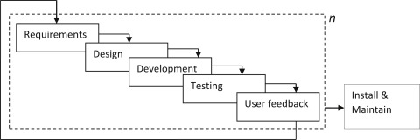

**FIG 1:-Incremental Model**

# 1.4 Language and tool used

The **Vegetable Inventory Management System** has been developed using the **C programming language,** one of the most widely used and fundamental programming languages in the field of computer science. C is considered a **middle-level language**, as it combines features of both low-level assembly programming and high-level programming constructs. It is known for its **speed, simplicity, and control,** which makes it a popular choice for developing system software, embedded systems, and console-based applications like this project.

We used Dev C++ to run the program. **Dev-C++** is an **Integrated Development Environment (IDE)** for programming in **C and C++.** It's a tool that helps you **write, compile, debug, and run** your programs easily in a single environment.

* 1. **Time schedule**

|  |  |  |  |  |  |  |
| --- | --- | --- | --- | --- | --- | --- |
| **Task No.** | **Task Description** | **Week 1** | **Week 2** | **Week 3** | **Week 4** | **Week 5** |
| 1 | Plan Features & Structure | ████ |  |  |  |  |
| 2 | Create Basic Menu & Input Handling | ████ | ████ |  |  |  |
| 3 | Implement File-Based Add/View Functions |  | ████ | ████ |  |  |
| 4 | Implement Sell Item & Update Inventory |  |  | ████ | ████ |  |
| 5 | Add Search/Delete/Edit Functionality |  |  |  | ████ |  |
| 6 | Add Sales Record & Total Value Calculation |  |  |  | ████ | ████ |
| 7 | Final Testing & Debugging |  |  |  |  | ████ |
| 8 | Documentation & Comments |  |  |  |  | ████ |

**CHAPTER 2: SYSTEM REQUIREMENT:**

To run the **Vegetable Inventory Management System** developed in C, the following **minimum hardware and software requirements** are recommended. The system is lightweight and designed to work efficiently on even older machines, making it accessible for small businesses or individual users with basic computer setups. This system does **not require internet access** or high-end resources, making it ideal for standalone use in local environments such as small shops. The minimum requirements for the system are:

### **Hardware Requirements:**

* **Processor:** Pentium II (260 MHz) or later
* **RAM:** Minimum 32 MB (Higher recommended for better performance)
* **Monitor:** Color Monitor (preferably, for better readability)
* **Storage:** Minimum 50 MB of free hard disk space
* **Input Devices:** Keyboard (essential), Mouse (optional)
* **Output Devices:** Standard Display

* 1. **Software Requirements :**
* OS Windows ( Windows XP, Windows 7, Windows 8, Windows 10)

# CHAPTER 3: SYSTEM DESIGN

**3.1 Introduction to the project**

The retail and grocery sector plays a vital role in ensuring the daily supply of fresh produce, especially vegetables, to consumers. Managing vegetable stock manually can often lead to errors, delays, and inefficiencies. To overcome these challenges at a basic level, a simple yet effective Vegetable Inventory Management System has been developed using the C programming language.

This system is designed to assist small vendors and storekeepers in keeping track of their vegetable inventory through a command-line interface, providing core functionalities needed for day-to-day operations**.**

**3.2 Algorithm:**

An algorithm is a well-defined, step-by-step procedure or set of rules designed to solve a specific problem or to perform a specific task. The system consists of different sets of algorithms:

Step 1 : Start Program

Step 2 : Display a welcome message

Step 3 : Display Menu

Present options: add vegetable, view inventory, sell vegetable, sales record, search record, delete record, edit record, exit.

Step 4 : Get user choice

Step 5 : Repeat menu until exit

Step 6 : Stop

* 1. **Flowchart**

A **flowchart** is a **diagram** that shows the steps of a process or program using different shapes and arrows. It helps to **visually explain how a program works or how a task is done**, step by step.

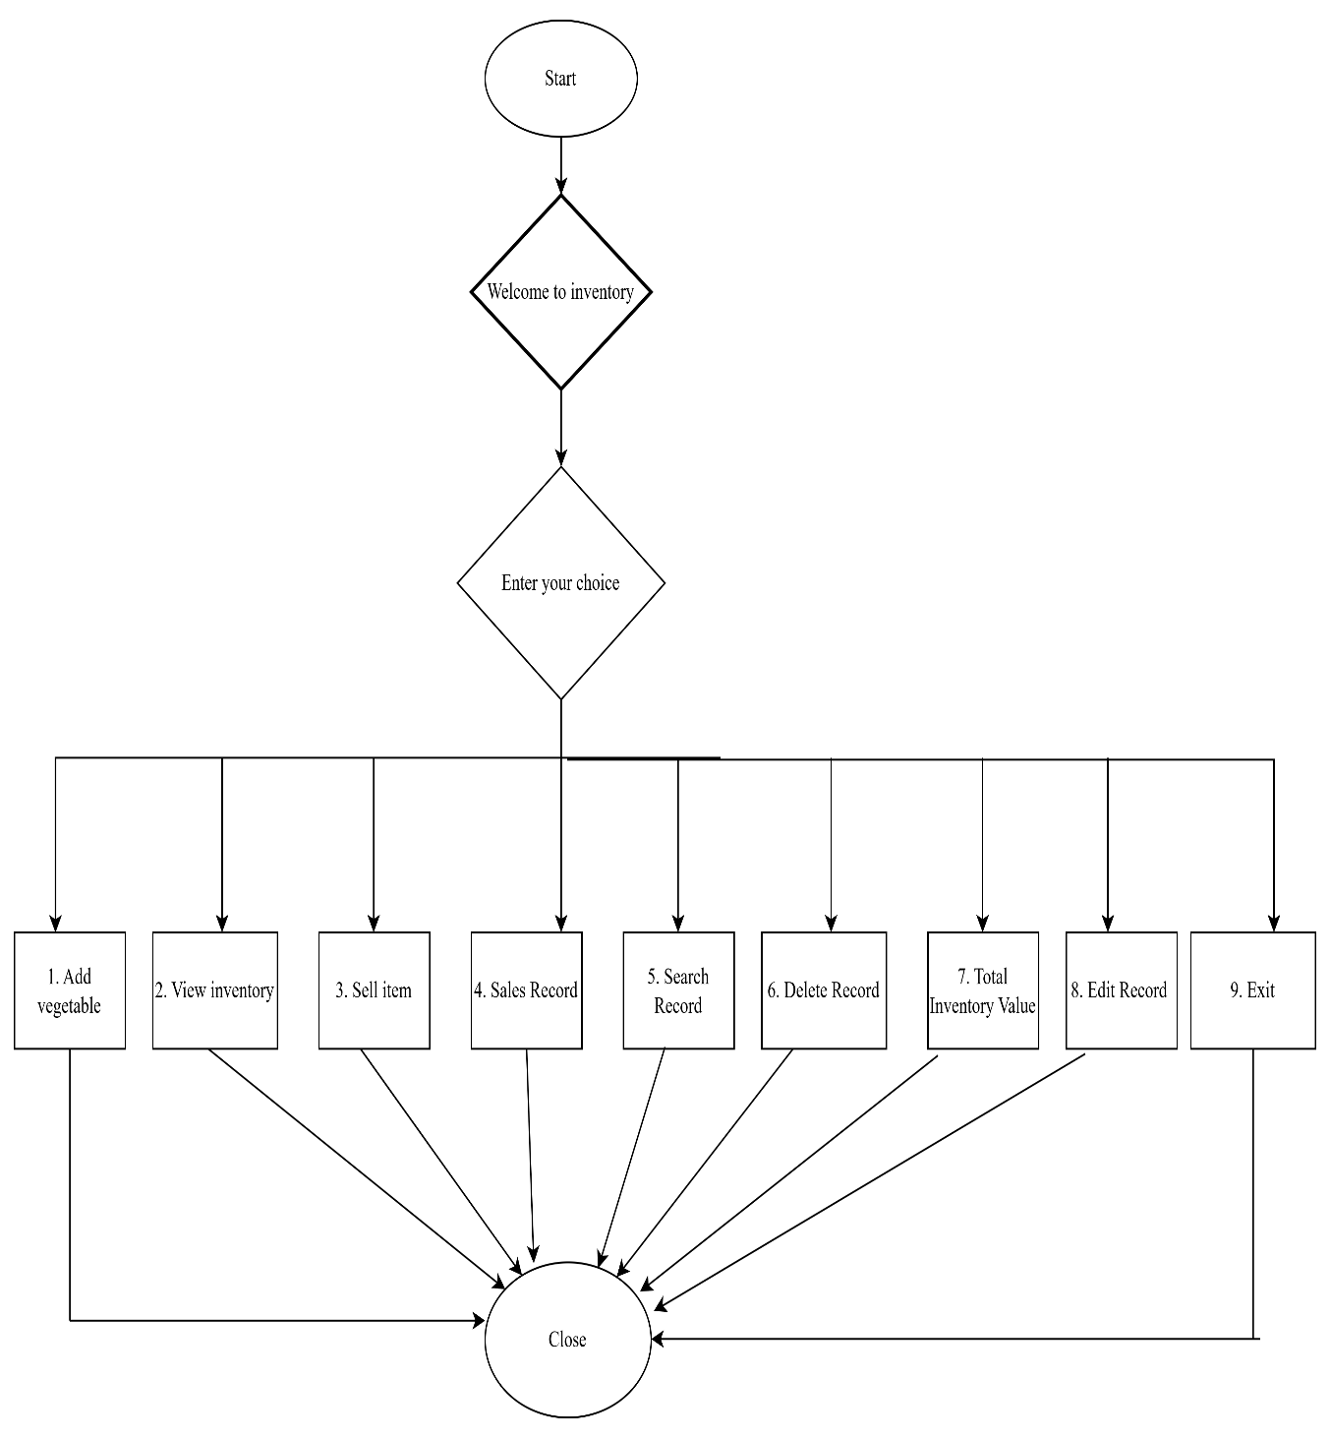

**FIG 2 :- Flowchart**

# 

* 1. **System Requirement**
     1. **Functional Requirement**
  2. Add Vegetable

User can add name, price and quantity of vegetable

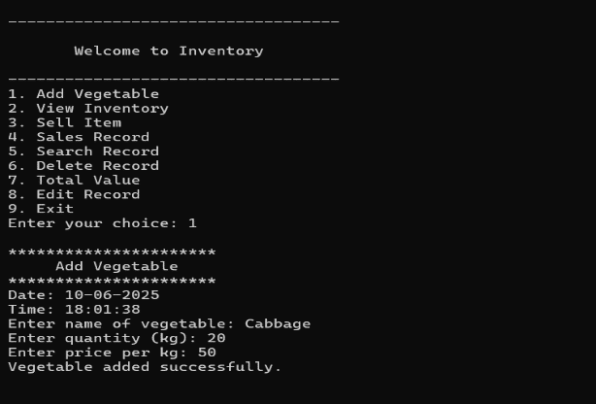

**Fig 3.4.1:-Add Vegetable**

* 1. View Inventory

User can view the records

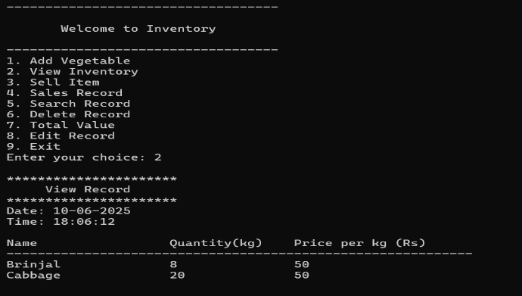

**Fig 3.4.2:- View Inventory**

* 1. Sell Vegetable

User can enter the name of vegetable and quantity to sell.

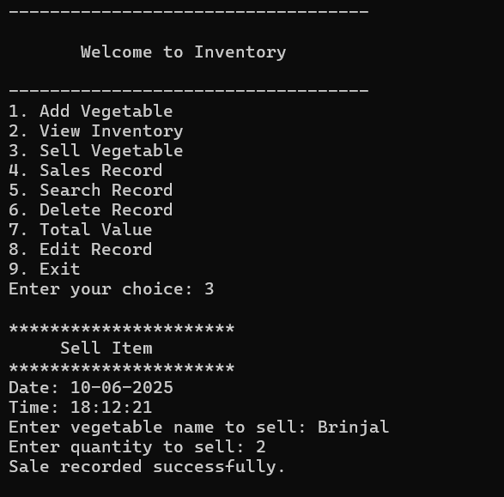

**Fig 3.4.3:-Sell Vegetable**

* 1. Sales Record

User can view the name, original, sold and remaining vegetable quantity

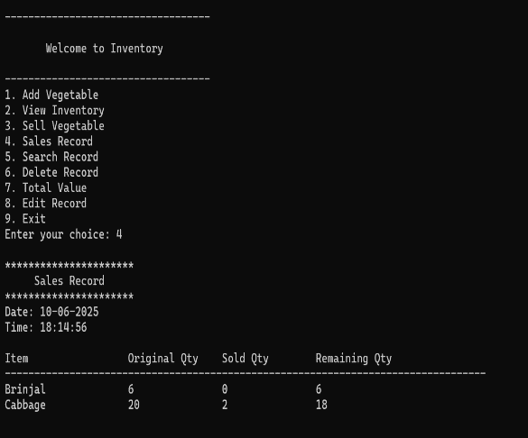

**FIG 3.4.4:-Sales Record**

* 1. Search Record

User can enter the name of vegetable to search.

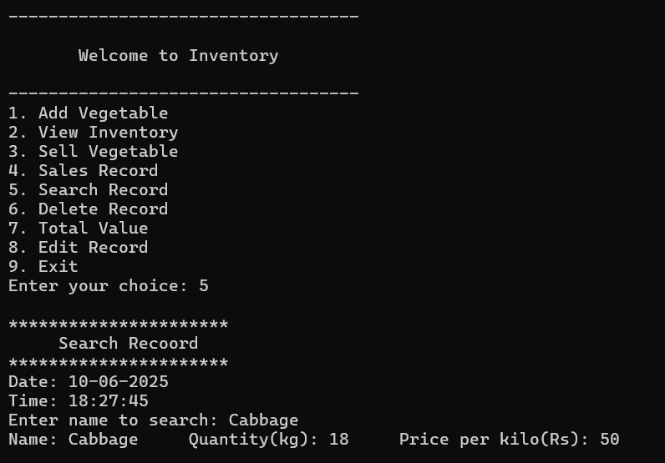

**Fig 3.4.5:- Search Record**

* 1. Delete Record

User can enter the name of vegetable to delete it.

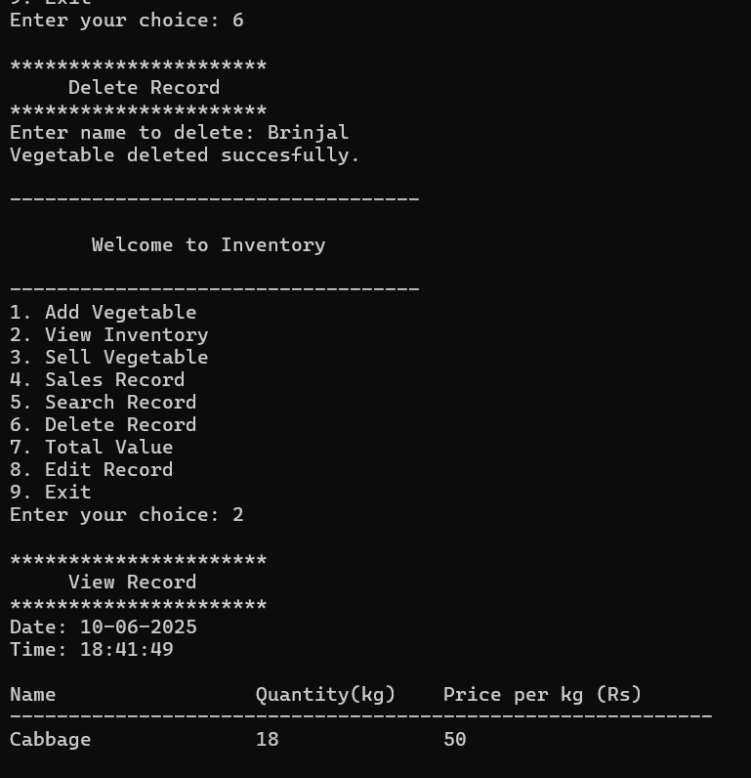

**Fig 3.4.46:- Delete Record**

* 1. Total Value

It shows total value of each vegetable based on the quantity and price per kg and total value of vegetable in inventory.

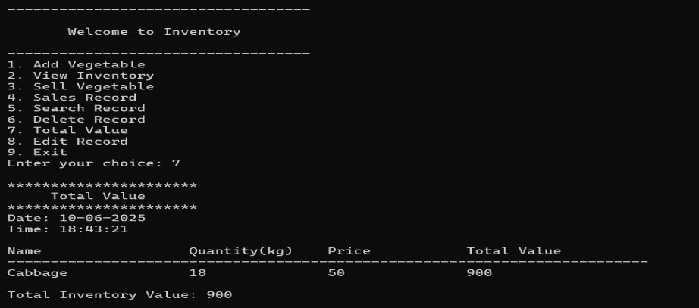

**Fig 3.4.7:- Total Value**

* 1. Edit Record

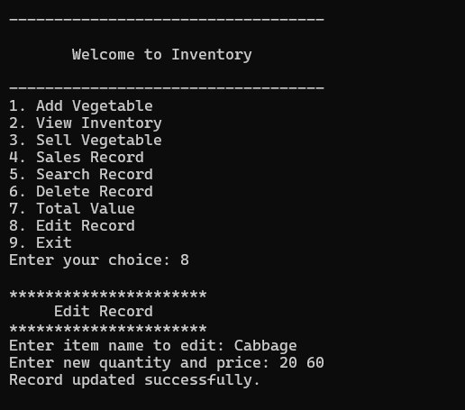 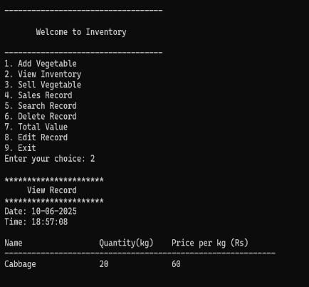

**Fig 3.4.8:- Edit Record**

**3.4.2 Non functional requirement**

**Non-functional requirements** describe **how a system should work**, rather than what it should do. They focus on the **quality, performance, security, usability, and reliability** of the system. These requirements focus on the quality and performance of the system, including aspects like speed, security, reliability, and usability. In this inventory management system, the program should respond to user inputs quickly, and display records or search results within a short time, ensuring good performance. The system should be easy to use, with a simple and clear console interface that even non-technical users can understand. It should also be reliable, meaning it should handle errors properly, such as displaying appropriate messages when a file is missing or when invalid inputs are entered. Additionally, the system should be easy to maintain and update in the future as new features are added. Though this project uses text files, it is recommended to follow proper data handling practices to maintain data integrity and avoid loss. These non-functional requirements help ensure the program runs smoothly and is convenient for the users.

**CHAPTER 4: CONCLUSION**

* 1. **Problems Faced**

The main problem faced while developing this software are as follows:

* Since the entire program was developed using C, which follows a procedural approach, it required writing a lot of code to handle even small tasks such as file operations and menu navigation. Managing program flow and user input validation was sometimes complex and required careful planning
* One of the core features of this project is storing and retrieving data using files. Initially, understanding file operations (read, write, append, update) in C was challenging, especially for managing records consistently and avoiding data loss.
* Tracking bugs in a C program can be difficult, especially in the absence of built-in debugging tools and clear error messages. Logical errors, such as incorrect pointer usage or file handling mistakes, required significant time to identify and fix.
  1. **Lesson learned**

While doing this project, I learned many useful things that will help me in future projects too. Some of the important lessons I learned are:

* Planning before starting makes it easier to finish the project without problems.
* Learned how to use files in C to save and load data like inventory and sales.
* Understood that we must check if files open properly to avoid errors.
* Realized that even in simple programs, a clear and neat display for the user is important.
* Found out that using separate functions for each task makes the program easy to manage and fix.
* Managed my time properly to complete everything on time.
* Understood the value of keeping notes and records during the project.

# Conclusion

The **Vegetable Inventory Management System** developed using the C programming language serves as a basic yet effective tool for managing vegetable stock in small shops or local businesses. By automating essential functions such as adding, viewing, deleting, selling, and searching inventory items, the system helps reduce manual errors and saves valuable time.

Although the system has certain limitations, such as the lack of a graphical user interface, multi-user support, and database integration, it provides a solid foundation for inventory management and demonstrates key programming concepts like file handling, data structures, and procedural logic.

With further enhancements and modernization, such as incorporating a graphical interface, database connectivity, and security features, this project has the potential to grow into a comprehensive solution for vegetable inventory management.

Overall, this project successfully meets its objectives of simplifying inventory tasks and improving record accuracy for small-scale vegetable vendors.

* 1. **Recommendation**

After completing this inventory management system project, I would like to recommend some improvements for future development. It is advised to replace the current text file storage method with a proper database management system like MySQL to ensure better data security and easier data handling. The program should also be upgraded with a graphical user interface (GUI) to make it more user-friendly, especially for those who are not comfortable with console-based systems. Adding a login system with password protection would help prevent unauthorized access to important features such as deleting or editing records. Regular data backups should be maintained to avoid accidental loss of records. Additionally, features like a search filter, stock low alerts, and daily or monthly sales reports can be included for better inventory tracking and business management. It is also recommended to convert this system into a mobile or web-based application in the future for easier access from different locations. Lastly, proper error messages, confirmation prompts, and periodic updates based on user feedback should be considered to keep the system reliable and up to date.

* 1. **Future enhancement**

The future of this project lies in its potential to evolve and meet more complex inventory management needs. Although the current version of the **Vegetable Inventory Management System** is built as a simple, console-based C program, it sets a strong foundation for future development. Enhancing this project using modern technologies and advanced features will greatly improve usability, performance, and scalability.

Future implementations aim to provide **higher user satisfaction, better efficiency**, and **expanded functionality**. As technology advances, the limitations of this current system can be overcome through continuous improvement.

The following are the future scope for the project:-

* The system can be extended to support multiple users with different access roles (admin, manager, staff) enabling collaborative inventory management in larger setups. With a fully automated solution, lesser staff, better space utilization and peaceful work environment, the company is bound to experience high turnover.
* Introducing features to track expiration dates and notify the user about soon-to-expire vegetables would reduce spoilage and losses.
* Assign a unique identity number to each item. This makes searching, editing, and deleting more reliable, especially if multiple items have the same name.
* A feature like grouping vegetables into categories (e.g., leafy greens, root vegetables) for better organization and reporting can be added.
* By recording purchase prices and sale prices, the system could calculate the profit margin for each item and overall.

# BIBLIOGRAPHY

* <https://youtu.be/irqbmMNs2Bo>
* <https://hamrocsit.com/note/c-program/file-handling-in-c/>
* <https://www.studocu.com/row/document/tribhuvan-vishwavidalaya/information-technology/c-programming-notes/2664815>

**APPENDIX**

